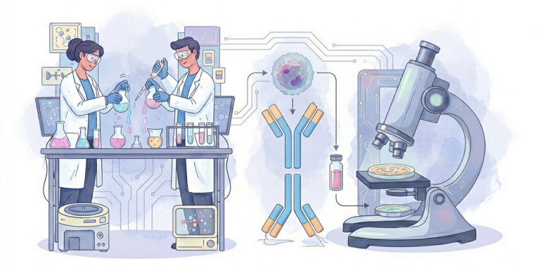
Thursday, October 1st, 2026.

14:00-24:00 HOTEL CHECK-IN
14:30-15:30 REGISTRATION
15:30-15:45 OPENING CEREMONY
15:45-16:30 INVITED LECTURE
Prof. Marco De Andrea
Viral Pathogenesis Unit, Department of Public Health and Pediatric Sciences, University of Turin, Medical School, Turin, Italy
TBA
16:30-17:15 SELECTED ORAL PRESENTATIONS – SESSION 1
Presentations will be selected based on the research abstract.
16:30 TBA
16:45 TBA
17:00 TBA
17:15-17:45 COFFE BREAK
17:45-18:30 INVITED LECTURE
Asst Prof Hrvoje Lalić
Department of Physiology and Immunology, University of Zagreb School of Medicine; Croatian Institute for Brain Research, University of Zagreb School of Medicine; Department of Laboratory Immunology, University Hospital Center Zagreb, Croatia
TBA
18:30-19:15 INVITED LECTURE
Prof Iva Hafner Bratkovič
National Institute of Chemistry, Ljubljana, Slovenia
TBA

Friday, October 2nd, 2026

9:00-9:45 INVITED LECTURE
Prof. Vivianne Malmström
Division of Rheumatology, Department of Medicine, Solna; Center for Molecular Medicine (CMM), Karolinska Institutet, Stockholm, Sweden
TBA
9:45-10:30 SELECTED ORAL PRESENTATIONS – SESSION 2
Presentations will be selected based on the research abstract
9:45 TBA
10:00 TBA
10:15 TBA
10:30-11:00 COFFEE BREAK

11:00-11:45 INVITED LECTURE
Prof. Joško Mitrović
Department of Clinical Immunology, Allergology and Rheumatology, University Hospital Dubrava, Zagreb, Croatia
TBA
11:45-12:45 SELECTED ORAL PRESENTATIONS – SESSION 3 - Bright Spark
Presentations will be selected based on the research abstract
11:45 TBA
12:05 TBA
12:25 TBA
12:45-14:30 BREAK for networking, sponsor exhibition, poster viewing, etc.
14:30-15:15 INVITED LECTURE
Asst Prof Ludovica Cacopardo
Department of Information Engineering, University of Pisa, Research Center ‘E. Piaggio’, Pisa, Italy
TBA
15:15-16:00 INVITED LECTURE
Asst Prof Maja Cokarić Brdovčak
Center for Proteomics, Faculty of Medicine, University of Rijeka, Croatia
TBA
16:00-17:30 POSTER SESSION
18:30 DINNER

Saturday, October 3rd, 2026

9:00-10:00 GENERAL ASSEMBLY OF THE CROATIAN IMMUNOLOGICAL SOCIETY
10:00-10:45 INVITED LECTURE
Asst Prof Vedrana Jelenčić
Department of Histology and Embryology, Faculty of Medicine, University of Rijeka, Croatia
TBA
10:45-11:30 SELECTED ORAL PRESENTATIONS – SESSION 4
Presentations will be selected based on the research abstract
10:45 TBA
11:00 TBA
11:15 TBA
11:30-12:00 COFFEE BREAK
12:00-13:00 AWARD CEREMONY AND CLOSING REMARKS

